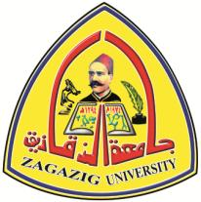 Zagazig University

Faculty of Veterinary Medicine

Department of Anatomy and Embryology

CURRICULUM VITAE
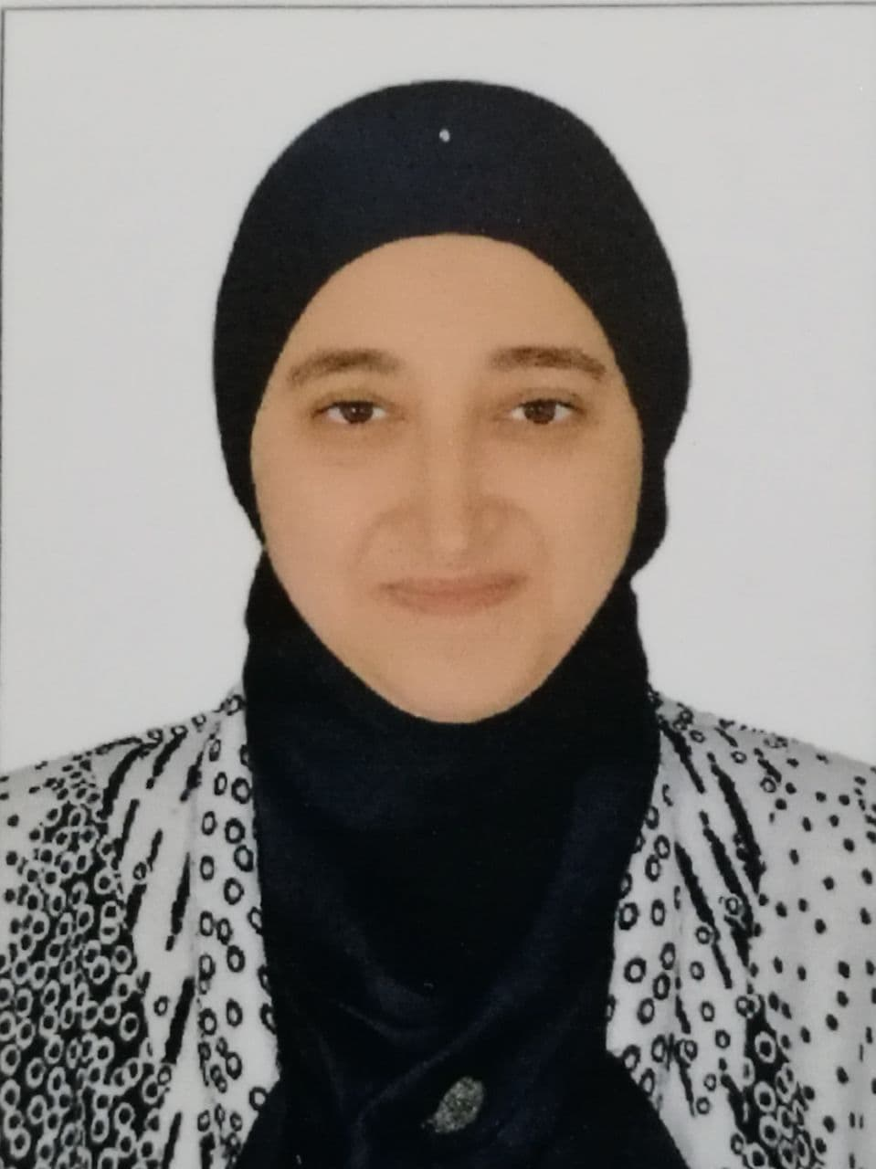

Name: Hanaa Mohamed El-Ghazali Ibrahim.

University: Zagazig University

Faculty: Faculty of Veterinary Medicine

Department: Department of Anatomy and Embryology

Country: Egypt

E-mail: dr_h1980@hotmail.com
Fax: 055-2283683 (work)

Mobile: +201223502010 - +201013977720

Phone: +2055-2301050 (home)

Date of Birth: 2/3/1980

Place of Birth: Sharkia-Egypt.

Nationality: Egyptian.

Marital status: Married.

Current position: Assistant professor of Veterinary Anatomy and Embryology, Department of Anatomy and Embryology, Faculty of Veterinary Medicine, Zagazig Univerisity.

Academic Qualification:

Degree year field institution

B.V.Sc 2002 Vet. Medicine Zagazig Univ.

M.V.Sc 2008 Vet. Anatomy Zagazig Univ.

PH.D 2013 Vet. Anatomy Zagazig Univ.

MSc & PhD Projects:

MSc Dissertation: Some morphological studies on the cerebellum of

balady goat.

MSc Supervisors: Prof. Dr.Hassan Anis Mohamed

Prof. Dr.Ibrahim Mohamed Salem Khidr

Prof. Dr.Khalid Zakaria Soliman

Prof. Dr.Salah El-Deen Abdel-Aziz

PhD Dissertation: Some Morphological Studies On The Stomach Of

Some Birds.

PhD Supervisors: Prof. Dr.Ibrahim Mohamed Salem Khidr

Prof. Dr.Ahmed Mohamed El-Sayed Omar

Prof. Dr.Khalid Zakaria Soliman

Experience

Position Year Field Institution

1- Demonstrator 2002-2008 Vet. Anatomy Zagazig Univ

2- Assist. Lecturer 2008-2013 Vet. Anatomy Zagazig Univ.

3- Lecturer 2013-2019 Vet. Anatomy Zagazig Univ.

4- Assistant professor 2019 till now Vet. Anatomy Zagazig Univ.

5- The chief coordinator of the Department of Anatomy and Embryology in Quality Management Unit since 2012.

6- Secretary of the Department Council (Department of Anatomy and Embryology, Faculty of Veterinary Medicine, Zagazig Univerisity) for the academic year 2016 till 2020.
7- Member of the VET- ELearning Unit (VET-ELU), Faculty of Veterinary Medicine, Zagazig Univerisity.
8- Head of the Department of Anatomy and Embryology (2021-2022).
9- General Supervisor of Academic Guidance, first level of general program, credit hours (2023-2024).

Languages

Mother language: Arabic.

English

Speaking: very Good

Writing: very Good

Understanding: very Good

Homepage

http://www.hmalghazaly.faculty.zu.edu.eg/

http://www.researchgate.net/profile/Drh_Mohamed

http://orcid.org/0000-0002-1769-5895

https://www.facebook.com/pg/Veterinary-Anatomy-

847763368607645

Research interest:
1- Plastination.
2- Anatomy Education by recent technique.
3- Cast models.
4- Injected specimens.
5- Microcirculation.

Publications:
1- Soliman Kh Z, Omr A M and El-Ghazali H M (2012): The Gastric Innervation In Hoopoe And Ibis With Special Reference To Ganglion Celiacum And Myenteric Plexus. Zag.Vet.J.(ISSN.1110-1458)Vol.40 No.6.Pp.113-122.
2- Omr A M, Soliman Kh Z and El-Ghazali H M (2012): Anatomical Studies On The Goose Stomach Vasculature. Zag.Vet.J. (ISSN.1110-1458) Vol.40 No.6.Pp.99-112.
3- Omar, A. M. and El-Ghazali, H.M. (2016): Quantitative Developmental Studies on the Otolith of Tilapia nilotica (Oreochromis niloticus) with Reference to Weight and Length. Zagazig Veterinary Journal, 44 (2): 177-186.
4- El-naseery, N.I.; El-behery, E.I.; El-Ghazali, H.M. and El-Hady E. (2016): The structural characterization of the lacrimal gland in the adult dog (Canis familiaris). Benha Veterinary Medical Journal, 31(2):106-116.
5- Attia A.A. Moselhy, Sherif Kh. A. Mohamed, Hanaa M. El-Ghazali. ANATOMICAL FEATURES OF BONES AND BONY CAVITIES OF THE OSTRICH SKULL (STRUTHIO CAMELUS). Int J Anat Res 2018;6(2.3):5390-5398. DOI: 10.16965/ijar.2018.213
6- El-Ghazali H M and EI El-behery, 2018. Comparative macro-anatomical observations of the appendicular skeleton of New Zealand rabbit (Oryctolagus cuniculus) and domestic cat (Felis domestica) thoracic limb. Inter J Vet Sci, 7(3): 127-133.
7- Hanaa M. El-Ghazali and Sozan A. Ali, 2018. Rectal, Anal Gland: A Corrective Morphological Study in New Zealand Rabbit (Oryctolagus cuniculus). Benha Veterinary Medical Journal, VOL. 34, NO. 2: 221-233.
8- El-Ghazali H M and EI El-behery, 2018. Comparative Morphological Interpretations on the Bones of the Pelvic Limb of New Zealand Rabbit (Oryctolagus cuniculus) and Domestic Cat (Felis domestica). Journal of Advanced Veterinary and Animal Research, J Adv Vet Anim Res, 5(4): 410-419.
9- Hanaa M. El-Ghazali and Eman A. A. Mahdy, 2018. ABSENCE OR PRESENCE OF TAPETUM LUCIDUM: MACRO AND MICROSCOPIC INVESTIGATIONS IN DONKEY (EQUUS ASINUS), CAT (FELIS DOMESTICA) AND ONE-HUMPED CAMEL (CAMELUS DROMEDARIUS). Slov Vet Res 2018; 55 (Suppl 20): 263–72.
10-Saleh A. M. A. ALomaisi,Hanaa M. El-Ghazali, Hamed M. Nosseur, Salah El-dein A. Ahmed, Mervat M. Konsowa (2018): Prenatal Development of the Nostril in Rabbit (Oryc- mtolagus cuniculus). J. Vet. Anat. 11(2): 57 – 68.
11-Eman I. El-beherya, Nesma I. El-naseeryb, Hanaa M. El-Ghazali, Yaser H.A. Elewa, Eman A.A. Mahdy, Enas El-Hady, Mervat M.H. Konsowa (2019): The efficacy of chronic zinc oxide nanoparticles using on testicular damage in the streptozotocin-induced diabetic rat model. Acta Histochemica 121:84–93.
12-Ahmed Abdelfattah-Hassan and Hanaa M. El-Ghazali (2019): EFFECTS OF DIET’S ACIDIFYING ADDITIVES ON THE INTESTINAL HISTOMORPHOLOGY
IN DUCKS. Slov Vet Res. 56 (Suppl 22): 219–28.
13- Saleh A. M. A. ALomaisi, Hanaa M. El-Ghazali, Hamed M. Nosseur, Salah El-dein A. Ahmed, Mervat M. Konsowa (2019): PRENATAL DEVELOPMENT OF THE VOMERONASAL ORGAN IN RABBIT. Slov Vet Res. 56 (Suppl 22): 623–32.
14- Hanaa M. El-Ghazali (2021): A Review on Molecular Factors Affecting Stomach Development. World Journal of Veterinary Science; 9: 31-39. https://doi.org/10.12970/2310-0796.2021.09.06
15- Hanaa M. EL-Ghazali, Saeed Mohammed Saleh Ammar, Sherif Kh. A. Mohamed, Mohamed Gomaa and Sahar Mohamed El-Sayed Ibrahim (2022): Topographic and morphometric study on the kidneys of Balady rabbit enhanced by ultrasonographic, radiographic and computed tomography scan. International Journal of Veterinary Science; 11(1): 28-36. https://doi.org/10.47278/journal.ijvs/2021.072
16- Wardah A. Alasmari, Ahmed Abdelfattah-Hassan, Hanaa M. El-Ghazali, Samar A. Abdo, Doaa Ibrahim, Naser A. ElSawy, Eman S. El-Shetry, Ayman A. Saleh, Mohammed A. S. Abourehab and Hala Mahfouz (2022): Exosomes Derived from BM-MSCs Mitigate the Development of Chronic Kidney Damage Post-Menopause via Interfering with Fibrosis and Apoptosis. Biomolecules; 12, 663. https://doi.org/10.3390/ biom12050663
17- Attia A.A. Moselhy and Hanaa M. El-Ghazali (2023): Gross, histological and electron microscopical features of the hard palate mucosa in the one-humped camel (Camelus dromedarius). Iraqi Journal of Veterinary Sciences, Vol. 37(3): 651-657. DOI: 10.33899/ijvs.2022.136534.2591
18- Mayada R. Farag, Heba S.A. Gharib, Karima El-Naggar, Basma M. Hendam, Enas A.M. Ahmad, Mahmoud Alagawany and Hanaa M. El-Ghazali (2023): Origanum majorana essential oil ameliorated the behavioral, biochemical, physiological and performance perturbations induced by aflatoxin B1 in growing rabbits. Annals of Animal Science, DOI: 10.2478/aoas-2023-0035
19- Hanaa M. El-Ghazali, Ahmed Abdelbaset-Ismail, Nehal I. A. Goda and Mohamed Aref (2023): Morphological, radiographic, three-dimensional computed tomographic, and histological features of the primary upstroke and downstroke muscles and bones in the domestic duck (Anas platyrhynchos domesticus) and the cattle egret (Bubulcus ibis, Linnaeus, 1758), reflecting the evolutionary transition towards the irreversible flightlessness. BMC Veterinary Research (2023) 19:133 https://doi.org/10.1186/s12917-023-03649-6
20- Hanaa M. El-Ghazali, Al-Sayed R. Al-attar and Attia A.A. Moselhy (2023): Some Anatomical and Histological Features of the Brain in African Catfish (Clarias Gariepinus). Journal of Advanced Veterinary Research;13(3): 455-460. ISSN: 2090-6277/2090-6269/

Supervision:

1- Supervising a master thesis of vet/ Sahar Mohamed El-sayed Ibrahim, entitle "Some morphological studies on the kidney of Balady rabbit by using the recent techniques" Faculty of Veterinary Medicine, Zagazig University. (The thesis had been finished and discussed in 2019)

2- Supervising a PhD thesis of vet/ Saleh Ahmed Mohamed Ali Alomaisi, entitle "Prenatal development of the nasal cavity in rabbit" Faculty of Veterinary Medicine, Zagazig University. (The thesis had been finished and discussed in 2019)

International conferences:
1- The 7th congress of the African Association of Veterinary Anatomists, Department of Anatomy and Embryology, Faculty of Veterinary Medicine, Suez Canal University, Egypt on 16th March 2019.
2- The Forty-third Annual Conference of the Egyptian Society of Histology and Cytology, National Research Center, Giza, Egypt on 26th December 2019.
3- The Forty-fifth International Conference on Medical Histology and Cells, held online on 9th December 2021.
4- The first international conference for students at the Faculty of Veterinary Medicine, Sadat University, held online on 9th -10th March, 2021.
5- The Forty-Sixth International Conference on Medical Histology and Cells, held online on 8th December, 2022.
Seminars:
1- Attending a symposium entitled (Open access for Egypt) under the sponsorship of The Egyptian Knowledge Bank and The STDF held online on 30th May, 2022.

Training courses and Workshops:
1- 6 training courses for promotion of assistant lecturer in Faculty and leadership Development center, Zagazig University.
2- 6 training courses for promotion of lecturer in Faculty and leadership Development center, Zagazig University.
3- Attending 6 training courses to promote assistant professor at the Center for Capacity Development of Faculty Members and Leadership at Zagazig University.

4- A workshop entitled “Basics of Scientific Writing” at Training Unit, Quality Management Unit, Faculty of Veterinary Medicine, Zagazig University on 27th March, 2019.

5- Attendance of training course entitled "Prezi presentation for Scientific Researches" at Training and Continuing Education Unit (TCEU) Zagazig University on 8th March, 2020.

6- A training course entitled “Effective teaching and learning strategies for colleges and institutes of higher education” on 7th -8th August, 2021.

7- Attending a training course entitled “Teaching Veterinary Anatomy and Histology During Covid-19 Pandemic, Challenges and Solutions” Academic Center for Conferences and Scientific Publishing - Malaysia (ACCSPM) conducted online on 11st March 2021.

8- A course entitled Examination Systems and Student Evaluation at the Center for Capacity Development of Faculty Members and Leadership at Zagazig University on 15th -17th February, 2022.

9- A course entitled Combating Corruption at the Center for Capacity Development of Faculty Members and Leaders at Zagazig University on 8th-10th March, 2022.

10- A course entitled “Using Global Databases” at the Center for Capacity Development of Faculty Members and Leadership at Zagazig University on 15th-17th March, 2022.

11- A course entitled Preparing competitive projects to finance research at the Center for Capacity Development of Faculty Members and Leadership at Zagazig University on 17th -19th May, 2022.

12- A course entitled Academic Guidance at the Center for Capacity Development of Faculty Members and Leaders at Zagazig University on 26th-28th July, 2022.

13- Military Diplomatic Representation Course No. 45, held under the supervision of the Military Intelligence and Reconnaissance Department “Military Attachés Service” in the period from 25/7-30/12/2020.

14- The training program in (the field of anti-corruption) for officers nominated for Egyptian military diplomatic representation positions abroad and their wives in the period from 21-25/11/2020.

